Georgian ASPIRE National Awareness Day 2016
The Georgian ASPIRE National Awareness Day 2016 actually consists of two events.
The first activity is the dissemination activity initiated by Ilia State University and open to other Georgian and Armenian participants of ASPIRE.
We refer to this as the “Child Development Institute” – please see further information on https://www.facebook.com/cadc.Clinic/?fref=ts .
This institute has become the main platform for dialogue concerning issues related to SEN children.
To follow the steps of ASPIRE in its post-project phase, alongside associated lectures and workshops, which are part of the main curricula for students with special need (see our modules on the ASPIRE website) and preschool tutors, this new institute has developed the strategy to conduct 8 public lectures about specific topics related to develop inclusive society and addressing the issues related to professional practice.
These discussions were launched from January 26th this year and will take place till December.
The major ASPIRE publicity was devoted to an Awareness Day on Autism as the main beneficiaries of the canter are children with autism.
To keep within the format of the ASPIRE programme we held two public discussion lectures on the 14thand 28th of June, The lecture was titled “Relevance of Applied Behavioural Analyses in Everyday Georgian Life”. The lecture audience was a mixed group of audience composed form students, lectures and general public.
In this way prominent Georgian professionals are promoting this as a burning issue relating to the ACTUAL application of ABA as it has become a major recipient of state funding in Georgia.
We would like to thank the ASPIRE Georgian Action Group for their efforts this year and to the EU Steering Group but especially the colleagues at Edge Hill University in the UK.
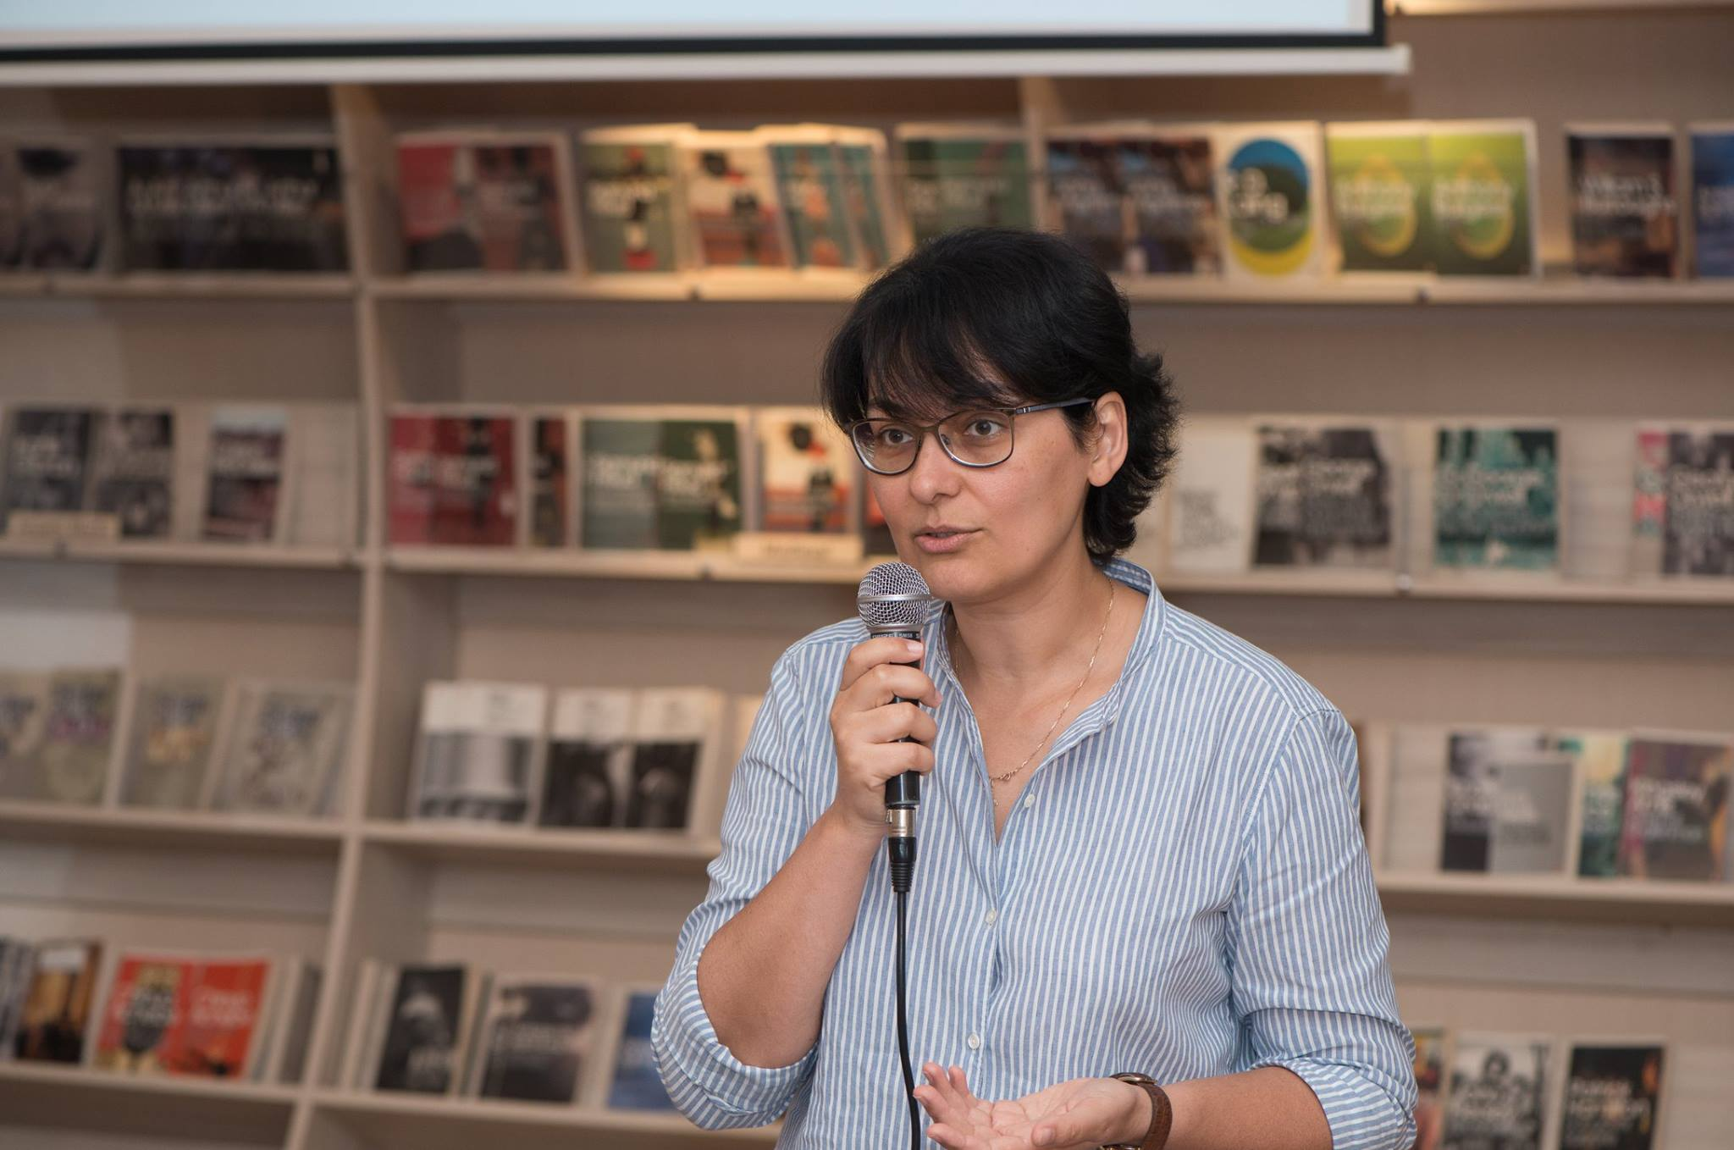
The second activity was an integrated action on September 24th targeted at an audience of schools, universities, non-governmental organizations, government agencies and institutions. The event platform used is the annual Science Picnic in Tbilisi is the location of the Georgian ASPIRE National Awareness Day 2016 and it consisted of a one-day, open air event, organized and sponsored by organisations such as the German and Polish Embassies who have been involved in ASPIRE promotion activities during the project lifetime, the Georgian Portage Association, Ilia State University and the German DAAD. The whole event, not just the ASPIRE National Awareness Day has become a major attraction reaching up to 20,000 visitors which is great for sustainability and dissemination for ASPIRE.
Please see the link:
http://sciencepicnic.iliauni.edu.ge/sciencepicnic/index.php/en/gallery-3/photo-gallery
The promotion of inclusion promoted by the ASPIRE EU Tempus has become a part of the Science Park mainstream activities and the Pavilion of Inclusive Education set up by the Georgian ASPIRE partners has housed its visitors for three years now.
This year we ran, in addition, a whole day session dedicated mainly for children by introducing the concept of inclusive participation with face painting, games and other activities.


