ASPIRE National Awareness Day, Armenia 2016
Dear Readers
This is the first ASPIRE event post-project National Awareness Day, Armenia held on our own initiative and using our own resources.
First of all we would like to thank all the Armenian partners, ASPU, PAARA, GSU, and EIU for the support in organizing it plus the co-operation with Georgian partners and in particular their SEN NGO, the Georgian Portage Association and the sponsorship afforded by World Vision. In addition, the Bridge of Hope expresses its readiness to support and actively participate in any initiative that will be suggested for 2017!.
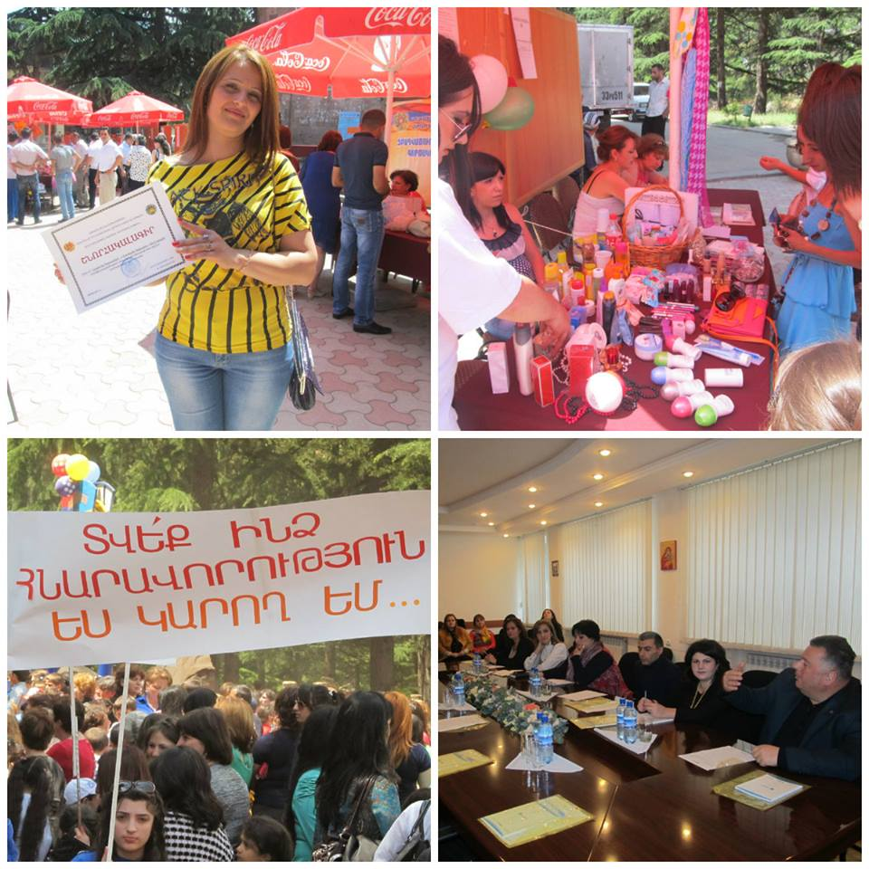
For your information, I would like to inform that during our ASPIRE 2016 National Awareness Day campaigns we held marketing meetings based on the ASPIRE objectives to use all available opportunities to foster the rights of youth with disabilities (YWDs) in order to access education and enjoy the right of participation in everyday society and to combat discrimination by instilling awareness and acceptance in society. We would like to especially thank the Pyramid Group for their support in organizing this event and coming to our marketing meeting in Yerevan in May on behalf of the EU Steering Group. Also for proofreading our report and modifications to our project modules over the past 12 months. In addition we would like to thank the representation sent by ILIA State University to Yerevan and the update on the Georgian ASPIRE National Awareness Day.
The ASPIRE National Awareness Day, Armenia 2016 event this year took place on 23 June and involved a series of föash mobs in public parks in Yerevan and Goris plus debates on university campus as there is still considerable resistance to our afore-mentioned project aims.
The highlight was a large Stakeholder Conference devoted to enhanced economic inclusion of youth with disabilities through improved access to education, information and livelihoods opportunities. This took place in Tavush marz, Armenia which is close to the Georgian border (see below).
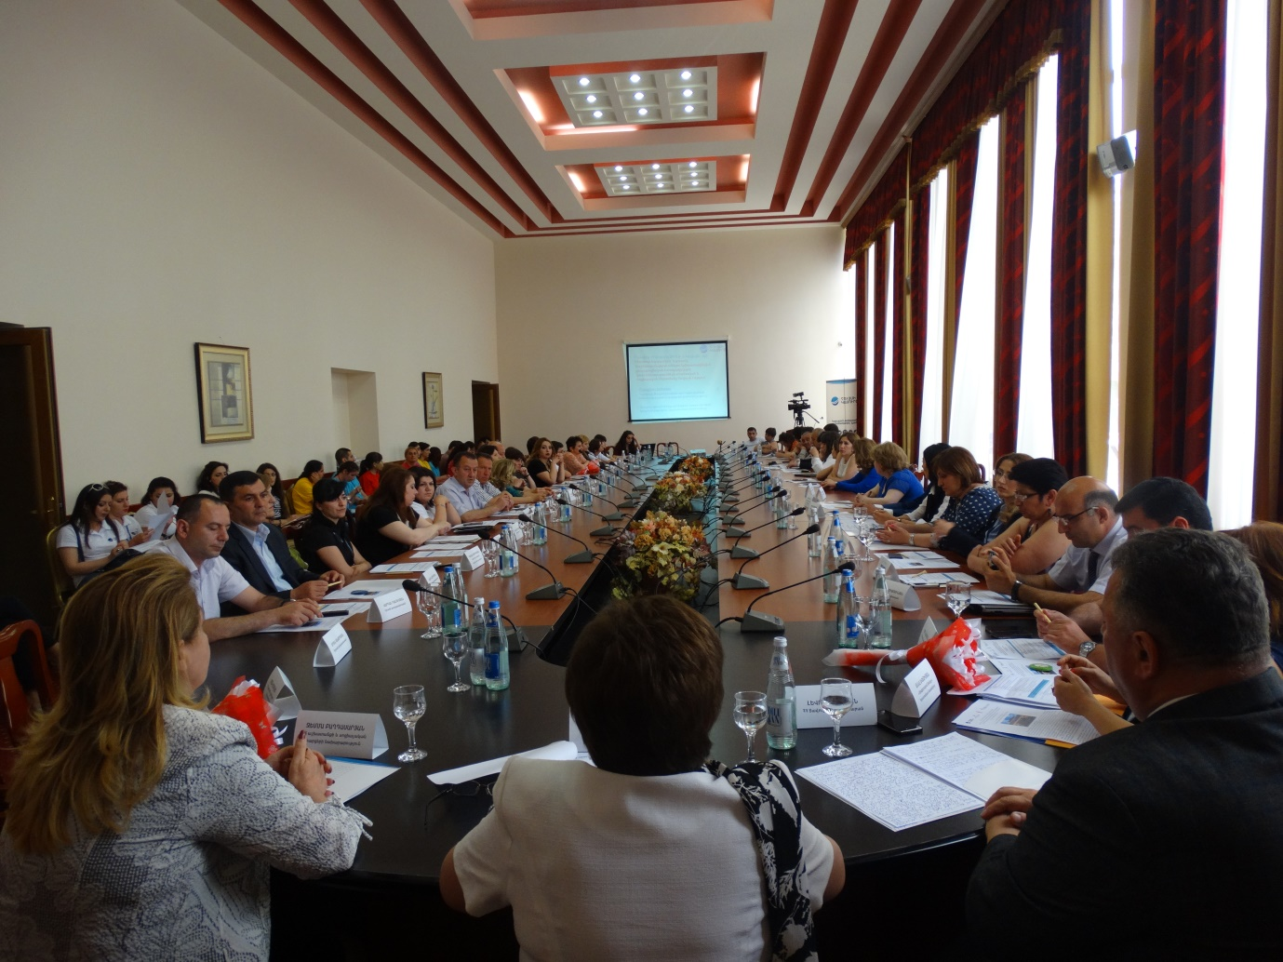

We look forward to working again with you in 2017 and plan a meeting in October at BoH.

Armenian ASPIRE Action Group

